THE BEDROOM CODER IS BACK!
Available August 30th on the Nintendo eShop
With FUZE⁴ Nintendo Switch you can create and share your own games and apps on Nintendo Switch
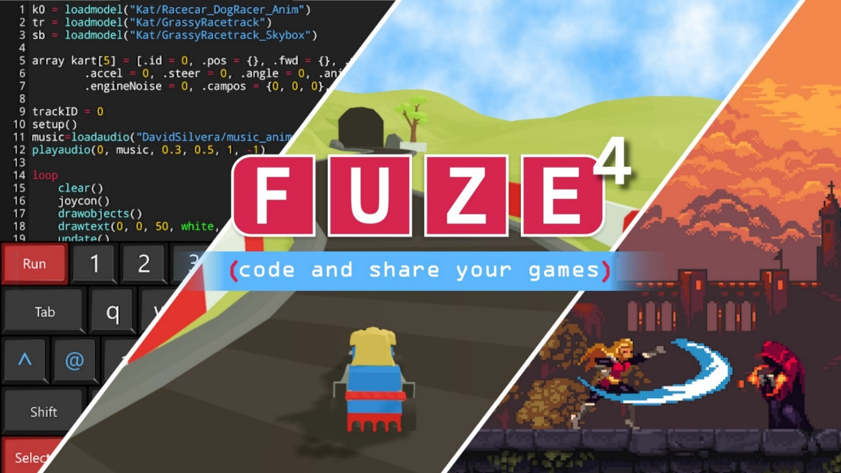

"FUZE⁴ Nintendo Switch is a great way to introduce young people to the world of coding - it's going to be really cool to see what comes out of it."
Nolan Bushnell - Founder of Atari, CEO in Stealth Mode
FUZE Technologies Ltd is proud to announce the official launch date for FUZE4 Nintendo Switch is the 30th of August. Jon Silvera, managing director commented, “After a number of delays and a rigorous testing process we’re thrilled to have received the final Nintendo stamp of approval. Now you can make your own games on Nintendo Switch in the comfort of your own bedroom!”
FUZE⁴ Nintendo Switch is a coding platform for Nintendo Switch. It has been designed and developed by a team of experienced gamers, programmers, artists and educators. Their sole intention has been to produce an environment ideally suited to coding games and apps for absolute beginners and seasoned programmers alike.
“FUZE4 Nintendo Switch represents a fantastic opportunity to help address the digital skills gap. Teaching coding from a gaming perspective is sure to enthuse, inspire and motivate young people and provide them with a valuable life skill, imperative to the future digital landscape.”
Ian Livingstone CBE - Founder Games Workshop, Director Sumo Group plc.

FUZE⁴ Nintendo Switch is a comprehensive ‘code studio’ including code editor, media browser, map editor, image editor, and the ability to share and collaborate on projects with your Nintendo Friends.
There are no limits to the kind of games and applications you can create. From text-based adventures to 2D shoot’em-ups, dungeon crawlers to solitaire, Minecraft style to golfing or 3D space exploration to 2D puzzle games, everything is possible.
Why learn to code?
The ability to code is widely considered to be one of the most important life skills across the curriculum. Perhaps more significant however is that the simple act of learning to code will help to improve your digital skills and offer an insight into how electronic devices actually work rather than just knowing how to use them.
“FUZE4 Nintendo Switch is a ground-breaking achievement. Making games is a fun way to learn important digital skills that employers desperately seek. This is how coding should be introduced and we hope this will have a significant impact.”
The Oliver Twins - Creators of Dizzy & the Guinness World Record holder for being ‘The Most Prolific 8 Bit Game Developers’
FUZE⁴ Nintendo Switch includes:
- More than 220 functions and commands
- Over $1,000 worth of 3D models, 2D sprites and sound files
- Sharing projects with your Nintendo Friends
- Comprehensive Programmer’s Reference guide, tutorials and help examples
- Intuitive, clear and minimal user interface
- Joy-Con, Touch and USB keyboard controls
- Flexible code editor with undo/redo, copy, paste, syntax highlighting, bookmarks and integrated help reference
- Powerful and extremely versatile programming language
- Advanced 2D engine with full sprite controls
- Incredible 3D Engine with lighting, shadows, deferred rendering, temporal anti-aliasing, high dynamic range rendering, 3D Camera, object scale, rotation and point functions
- Play music, sound FX and create your own with the built-in programmable synthesiser
- Joy-Con support including Gyro, Accelerometer, HD Rumble and Analog sticks
- More than 10,000 gaming assets across 2D, 3D and Audio
- Tile Map editor for creating your own 2D levels, backgrounds, top down maps and landscapes
- Image / Sprite editor to create unique graphics
- fuzearena.com - A community website for additional support, showcasing, tips, tricks and general coding antics!

F4NS comes fully loaded with thousands upon thousands of game assets in the form of 2D pixel art sprites, sprawling isometric landscapes, platform blocks and characters, RPG player graphics, 3D models, sound effects and music files. Also included, by kind permission of the Oliver Twins and Codemasters, is a fantastic collection of Dizzy retro gaming assets.

Join the community at fuzearena.com where you can share your projects with other users, create dev teams and work together to make your own gaming projects.
F4NS is available on the Nintendo eShop from August 30th across Europe, the USA and other English-speaking territories (UK £29.99, USD $39.99, Euro €34.99)
Related links
Official website:​ https://fuzearena.com
Press page: https://www.fuze.co.uk/press-page.html
Video: https://www.youtube.com/watch?v=8iiJlJ-dKDk

About FUZE Technologies:
UK-based FUZE Technologies Ltd has its roots in home computing and programming. Our many years of experience in the computer industry and our passion for technology innovation and computer programming have positioned us perfectly to expand our business into Programmable Computers and Electronics. The last five years has seen the development of FUZE for Linux, Raspberry Pi, Asus Tinker Board and Microsoft Windows. The team continues to deliver outstanding FUZE Coding Workshops to schools across the country and constantly receives incredibly positive praise and testimonials.
For more information on FUZE please see www.fuze.co.uk
Press Contact
Jon Silvera
jon.silvera@fuze.co.uk

