MADE WITH FUZE – SELL YOUR GAME ON NINTENDO SWITCH!
FUZE Technologies make the route to market for new developers more accessible than ever before!
SUPER FUNKY BOWLING, the debut ‘made with FUZE’ release, is coming to the Nintendo eShop!
September 27th, 2022 - FUZE Technologies are the creators of FUZE⁴ Nintendo Switch, an application designed to make learning real coding as accessible and beginner-friendly as possible. With its comprehensive suite of features and tutorial content, users can learn the fundamentals of coding in a forgiving environment, therefore removing the barrier to entry often found in professional platforms.
Made with FUZE
Made with FUZE is a channel for FUZE⁴ Nintendo Switch users to get their games on the Nintendo eShop, allowing them to start earning money for their games and leaving the complexities of publishing to FUZE.
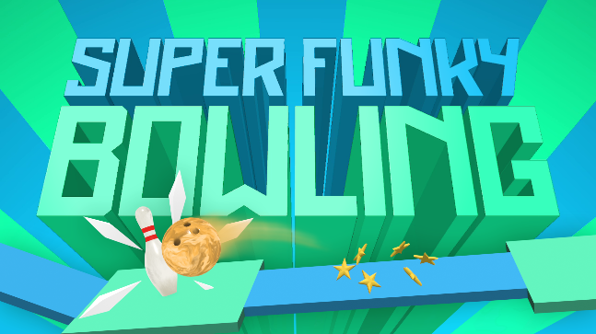
First Release
The debut ‘Made with FUZE’ release is the incredibly awesome ‘SUPER FUNKY BOWLING’ by FUZE community member Nathaniel Strub (aka. Scrubz). The game was created for a high-profile competition judged by industry veterans (including Jeff Minter, Eugene Jarvis and the Oliver Twins) and exemplifies beautifully what is possible in FUZE!
David Silvera, FUZE Product Manager, comments “This is all about lowering the barrier to entry for new developers, celebrating hidden talent and opening doors for people with less access to the support they need to get started.”
Over the past few years, FUZE has seen the creation of a thriving community of coders at every stage of their journey - enthusiastic beginners and seasoned programmers alike are sharing their knowledge, lifting others up and collaborating on awesome creative projects. Their work is celebrated by both FUZE and the community alike, fostering an environment of support and empowerment.
“Game development has always just been a fun hobby for me. I’ve never made a game expecting to make a profit from it. Sure, I’ve dreamt of publishing and selling my games somewhere special, but the process seemed too convoluted to be worth it. Then the FUZE team came along, took a game I made with FUZE, and did the hard work of putting it on the eShop for me! How awesome is that!” – Scrubz, Super Funky Bowling Developer.
Super Funky Bowling is available exclusively on the Nintendo eShop from October 14th 2022 for only 2.99 ($£€)
About FUZE
FUZE Technologies Ltd, Oxfordshire, England has a core focus on making learning to code as easy, accessible and enjoyable as possible. As well as local Coding & Gaming activities, FUZE provides award winning, curriculum-mapped, computing workshops to schools and STE(A)M events country-wide.
FUZE developed FUZE⁴ Nintendo Switch, an application designed to bring accessible coding, and even games publishing, to the world’s best-selling games platform and will soon announce versions for additional platforms.
Supporting its activities, FUZE offers freely downloadable teaching content, a vast number of YouTube coding tutorials and operates the FUZE Arena, a community driven platform for coding advice, creative inspiration, and events such as Game Jams and competitions.

To find out more about FUZE Technologies Ltd:
fuze.co.uk
For FUZE Arena, YouTube, Twitter & TikTok
fuzearena.com / @fuzearena
General & Education enquires: contact@fuze.co.uk
Press:
molly@fuze.co.uk
Press packs: fuze.co.uk/press.html

